WEEK 5- LAB 6(WEBAPI)
Kafka: zookeeper
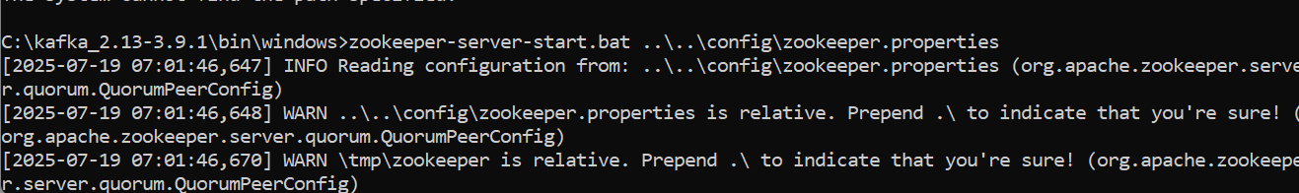
Kafka server start
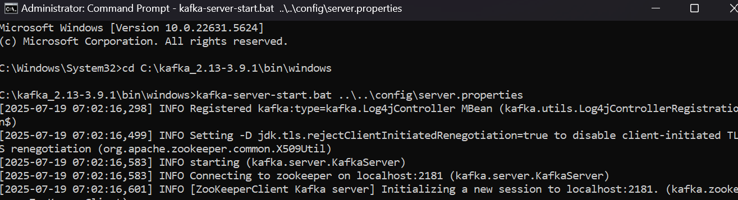
Chat sender side
using System;
using Confluent.Kafka;

class Program
{
static async Task Main()
{
var config = new ProducerConfig
{
BootstrapServers = "localhost:9092"
};

using var producer = new ProducerBuilder<Null, string>(config).Build();

Console.WriteLine("=== Kafka Chat Producer ===");
Console.WriteLine("Type your message and press Enter. Type 'exit' to quit.");

while (true)
{
Console.Write("You: ");
var input = Console.ReadLine();

if (input.ToLower() == "exit")
break;

await producer.ProduceAsync("chat-topic", new Message<Null, string> { Value = input });
}
}
}

Chat reciever

class Program
{
static void Main()
{
var config = new ConsumerConfig
{
GroupId = "chat-group",
BootstrapServers = "localhost:9092",
AutoOffsetReset = AutoOffsetReset.Earliest
};

using var consumer = new ConsumerBuilder<Ignore, string>(config).Build();
consumer.Subscribe("chat-topic");

Console.WriteLine("=== Kafka Chat Consumer ===");
Console.WriteLine("Waiting for messages...");

while (true)
{
var cr = consumer.Consume();
Console.WriteLine($"\nFriend: {cr.Message.Value}");
}
}
}

